**HOME ASSIGNMENT 3**

**Roll No: 208W1A1299**

**Name: MOHAMMAD RIZWANULLAH**

**Problem Statement :** Implementation of mongodb using Twitter dataset.

Start new connection:

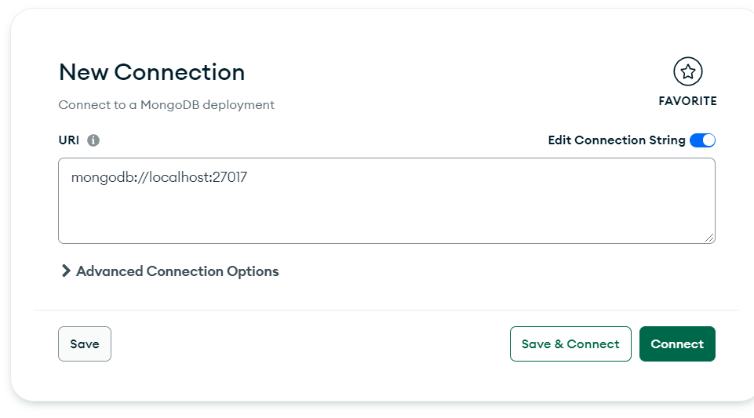

Import dataset into mongodb and convert into json format. And that can be used for analytics.

